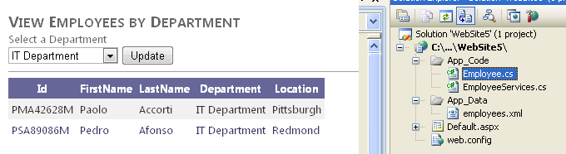

1. Open Visual Studio and create a new ASP.NET website called LinqExample.

2. Add the employees.xml file to the App_Data directory of your solution.

<Employees>
<Employee>
<ID>PMA42628M</ID>
<FirstName>Paolo</FirstName>
<LastName>Accorti</LastName>
<Department>IT Department</Department>
<Location>Pittsburgh</Location>
</Employee>
<Employee>
<ID>PSA89086M</ID>
<FirstName>Pedro</FirstName>
<LastName>Afonso</LastName>
<Department>IT Department</Department>
<Location>Redmond</Location>
</Employee>
<Employee>
<ID>VPA30890F</ID>
<FirstName>Victoria</FirstName>
<LastName>Ashworth</LastName>
<Department>Human Resources</Department>
<Location>Redmond</Location>
</Employee>
<Employee>
<ID>H-B39728F</ID>
<FirstName>Helen</FirstName>
<LastName>Bennett</LastName>
<Department>Marketing</Department>
<Location>Ann Arbor</Location>
</Employee>
<Employee>
<ID>L-B31947F</ID>
<FirstName>Lesley</FirstName>
<LastName>Brown</LastName>
<Department>Marketing</Department>
<Location>Ann Arbor</Location>
</Employee>
<Employee>
<ID>F-C16315M</ID>
<FirstName>Francisco</FirstName>
<LastName>Chang</LastName>
<Department>Human Resources</Department>
<Location>Pittsburgh</Location>
</Employee>
<Employee>
<ID>PTC11962M</ID>
<FirstName>Philip</FirstName>
<LastName>Cramer</LastName>
<Department>Sales</Department>
<Location>Chicago</Location>
</Employee>
</Employees>

3. Add a new class file called Employee to the solution.

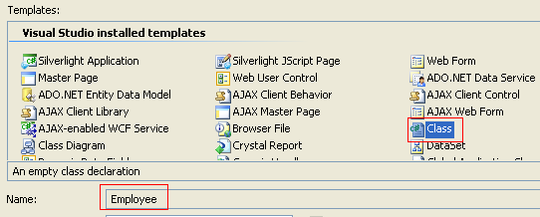
Visual Studio will ask to create the App_Code directory and add it to the solution for you; click Yes.

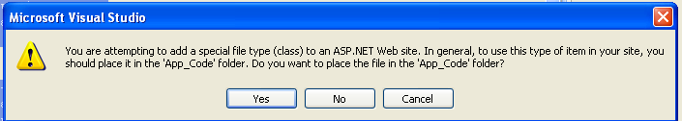

This class represents an employee object and will be used when the XML is turned into a collection of strongly typed objects. The following code shows an example.

VB | C#
Public Class Employee  Public Property Id As String  Public Property FirstName As String  Public Property LastName As String  Public Property Department As String  Public Property Location As String  End Class | public class Employee  {  public string Id { get; set; }  public string FirstName { get; set; }  public string LastName { get; set; }  public string Department { get; set; }  public string Location { get; set; }  }

The Employee Class is created to set the type of data we are expecting from the LINQ

4. Add a new class file called EmployeeServices to the solution. This class will expose methods that use LINQ to work with the XML file.

In the EmployeeService you will add
- System.Xml.Linq.
- A class-level variable that reads the XML file.
- Method to retrieve the departments from the XML file (GetDepts)
- Method to retrieve the list of employees by Department (GetEmployeesByDept)

The following shows an example of what your class should look like.

VB | C#
Imports Microsoft.VisualBasic  Imports System.Xml.Linq  Public Class EmployeeServices  Dim _empXml As XElement = XElement.Load( _  "C:\Training\App_Data\employees.xml") | using System;  using System.Collections.Generic;  using System.Linq;  using System.Xml.Linq;  public class EmployeeServices  {  XElement _empXml = XElement.Load(@"C:\Training\App_Data\employees.xml");

Note that you could read the XML file’s location from the Web.config file. This sample hard-codes the path to the XML file; you will most likely need to edit this.

7. Add a method called GetDepts to the EmployeeServices class. Write a LINQ query to return just the distinct departments from the XML file. You can do so by using Group By and then selecting only the first elements in the result. The following shows an example.

VB | C#
Public Function GetDepts() As List(Of String)  'query the XML and group by department  ' select only the departments in the group  Dim deptQuery =  From emp In _empXml.Descendants("Employee")  Group emp By emp.Element("Department").Value  Into empGroup = Group  Select empGroup.First().Element("Department").Value  Return deptQuery.ToList()  End Function | public List<string> GetDepts()  {  var deptQuery =  from emp in _empXml.Descendants("Employee")  group emp by emp.Element("Department").Value  into empGroup  select empGroup.First().Element("Department").Value;  return deptQuery.ToList();  }

8. Add another method to EmployeeServices. Name this method GetEmployeeByDept. This method takes a department name as a parameter. It will then query the employee.xml file and return departments with a matching name. The query will transform the data into a list of Employee objects. The following code shows an example.

VB | C#
Public Function GetEmployeesByDept(ByVal department As String) _  As List(Of Employee)  'query the XML list by department and return a list of  ' Employee(objects)  Dim empQuery As IEnumerable(Of Employee) =  From emp In _empXml.Descendants("Employee")  Where emp.Element("Department").Value = department  Select New Employee With {  .Id = emp.Element("ID").Value,  .Department = emp.Element("Department").Value,  .FirstName = emp.Element("FirstName").Value,  .LastName = emp.Element("LastName").Value,  .Location = emp.Element("Location").Value  }  Return empQuery.ToList()  End Function | public List<Employee> GetEmployeesByDept(string department)  {  //query the XML list by department and return a list of Employee objects  IEnumerable<Employee> empQuery =  from emp in _empXml.Descendants("Employee")  where emp.Element("Department").Value == department  select new Employee  {  Id = emp.Element("ID").Value,  Department = emp.Element("Department").Value,  FirstName = emp.Element("FirstName").Value,  LastName = emp.Element("LastName").Value,  Location = emp.Element("Location").Value  };  return empQuery.ToList();  }

The Employee Class is created to set the type of data we are expecting from the LINQ

9. Open the Default.aspx page, add.
- A DropDownList,
- A Button
- A GridView
- An ObjectDataSource control.

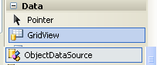

10. Configure the ObjectDataSource to point to the EmployeeServices.GetDepts method. (See Chapter 12, “Working with Data Source Controls and Data-Bound Controls” for more information on ObjectDataSource.)

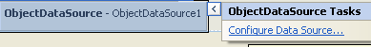

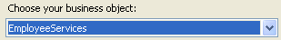

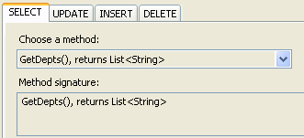

IF YOU ARE NOT ALLOW TO SEE THE METHOD REBUILD THE APPLICATION

11. Configure the DropDownList to use the ObjectDataSource.

In the properties: DataSourceID = ObjectDataSourceDepts

12. Add a click event to the Button control. Inside the code for the click event, call the EmployeeServices.GetEmployeesByDept method and pass the selected method from the DropDownList. Update the data in the GridView control with the results. This code should look similar to the following.

VB | C#
Protected Sub Button_Click(ByVal sender As Object, _  ByVal e As System.EventArgs) Handles ButtonUpdate.Click  Dim empl As EmployeeServices = New EmployeeServices()  GridView1.DataSource =  empl.GetEmployeesByDept(DropDownDepts.SelectedItem.Text)  GridView1.DataBind()  End Sub | protected void Button_Click(object sender, EventArgs e)  {  EmployeeServices empl = new EmployeeServices();  GridView1.DataSource =  empl.GetEmployeesByDept(DropDownDepts.SelectedItem.Text);  GridView1.DataBind();  }

Your markup inside the MainContent placeholder should look similar to the following.

<asp:Content ID="BodyContent" runat="server" ContentPlaceHolderID="MainContent">
<h2>View Employees by Department</h2>

Select a Department<br />

<asp:DropDownList ID="DropDownDepts" runat="server"
DataSourceID="ObjectDataSourceDepts">
</asp:DropDownList>

<asp:Button ID="ButtonUpdate" runat="server" Text="Update" onclick="Button_Click" />
<hr />

<asp:GridView ID="GridView1" runat="server" CellPadding="4"
ForeColor="#333333" GridLines="None">
<AlternatingRowStyle BackColor="White" ForeColor="#284775" />
<EditRowStyle BackColor="#999999" />
<FooterStyle BackColor="#5D7B9D" Font-Bold="True" ForeColor="White" />
<HeaderStyle BackColor="#5D7B9D" Font-Bold="True" ForeColor="White" />
<PagerStyle BackColor="#284775" ForeColor="White" HorizontalAlign="Center" />
<RowStyle BackColor="#F7F6F3" ForeColor="#333333" />
</asp:GridView>

<asp:ObjectDataSource ID="ObjectDataSourceDepts" runat="server"
SelectMethod="GetDepts"
TypeName="EmployeeServices">
</asp:ObjectDataSource>

</asp:Content>

13. Run your application. Select a department and click the Update button. Your results should look similar to those in Figure 11-1.

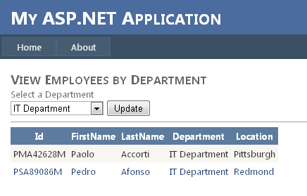

Nota: La clase Employee se genera para que el LINQ la utilize

public List<Employee> GetEmployeesByDept(string department)
{
//query the XML list by department and return a list of Employee objects

IEnumerable<Employee> empQuery =
from emp in _empXml.Descendants("Employee")
where emp.Element("Department").Value == department
select new Employee
{
Id = emp.Element("ID").Value,
Department = emp.Element("Department").Value,
FirstName = emp.Element("FirstName").Value,
LastName = emp.Element("LastName").Value,
Location = emp.Element("Location").Value
};

return empQuery.ToList();
}

File: EmployeeServices.cs

using System;
using System.Collections.Generic;
using System.Linq;
using System.Web;
using System.Xml.Linq;

/// <summary>
/// Summary description for EmployeeServices
/// </summary>
public class EmployeeServices
{
XElement _empXml = XElement.Load(@"C:\NET\Training 70515\Sample Files\Chapter11\Lesson1-Exercise1-Completed-CS\LinqExample\App_Data\employees.xml");

public List<string> GetDepts()
{
var deptQuery =
from emp in _empXml.Descendants("Employee")
group emp by emp.Element("Department").Value
into empGroup
select empGroup.First().Element("Department").Value;

return deptQuery.ToList();
}

public List<Employee> GetEmployeesByDept(string department)
{
//query the XML list by department and return a list of Employee objects

IEnumerable<Employee> empQuery =
from emp in _empXml.Descendants("Employee")
where emp.Element("Department").Value == department
select new Employee
{
Id = emp.Element("ID").Value,
Department = emp.Element("Department").Value,
FirstName = emp.Element("FirstName").Value,
LastName = emp.Element("LastName").Value,
Location = emp.Element("Location").Value
};

return empQuery.ToList();
}

public EmployeeServices()
{
//
// TODO: Add constructor logic here
//
}
}

FILE: Employee.cs

using System;
using System.Collections.Generic;
using System.Linq;
using System.Web;

/// <summary>
/// Summary description for Employee
/// </summary>
public class Employee
{
public string Id { get; set; }
public string FirstName { get; set; }
public string LastName { get; set; }
public string Department { get; set; }
public string Location { get; set; }
}

